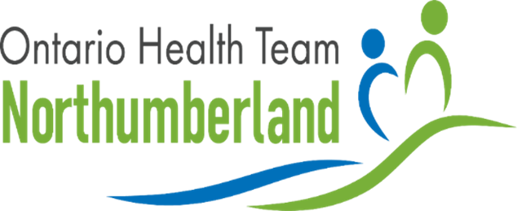

Volunteer Peer Support - WrapAround
VOLUNTEER FACILITATOR TRAINING

Upcoming Two-Part Comprehensive Training in WrapAround
Are you interested in an in-depth introduction to the values, principles, and practices of WrapAround? Come to the one-day introduction session.
Are you interested in becoming a Volunteer Facilitator for the Peer Support Program? Come to the full four-day training program (includes introduction).

When:
February 27 (one-day introduction session)
February 27, 28 and March 6, 7 (four-day WrapAround training)

Where:
Ed's House Education Room
1301 Ontario Street, Cobourg ON

Introduction to WrapAround
The Volunteer Peer Support (VPS) program—one of three programs of the Ontario Health Team of Northumberland (OHT-N)—will see well-trained peer volunteer facilitators support Northumberland older adults and their caregivers experiencing persistent complex problems and conditions with an innovative new WrapAround model.

The VPS program matches skilled volunteers with vulnerable older people experiencing persistent complex problems and conditions. The volunteers will be trained to deliver a consistent, prescribed method of support (High-Fidelity WrapAround) and will work together with the participant and as appropriate, their caregiver, to build an individualized team of support. These teams will support the participant to build on their strengths and find ways to address their unique needs and goals. Through this informal, social support circle, it is expected that the person will begin to develop greater capacity to both navigate and get the most out of available local service systems.

Volunteer Skills/Experience
The following skills and experience would be helpful for WrapAround Volunteer Facilitators: Experience supporting older adults (e.g. as a friend or family caregiver) an asset
Other volunteering and volunteer training Excellent communication and listening skills
Ability to form professional and comfortable working relationships with a wide range of people Empathic and caring
General knowledge of:
Community support groups (faith communities, seniors' programs/centres, service clubs) Health care and social services available throughout Northumberland County
Volunteers must also adhere to the organization's vaccine policy.

Training Costs
FREE. The one-day introduction session and the four-day training program will be covered by the Volunteer Peer Support Program.
Agencies interested in having staff trained in WrapAround, are encouraged to reach out to the coordinator for training costs.

For consideration, please indicate your interest by completing the following application and returning it via email to Kelly Peterson, Volunteer Peer Support Coordinator, at
k.peterson@commcare.ca. Phone inquiries are also welcome at Office: 905-372-7356 x102 or Cell: 905-373-2998.

For more information on the Ontario Health Team of Northumberland (OHT-N) please visit the team's website at wwww.ohtnorthumberland.ca or email them directly at
info@ohtnorthumberland.ca.

APPLICATION

One-Day Introduction

Four-Day Introduction & Training

Name:

Referring Organization:

Phone #: Email: Organization Role & Reason For Interest:

Note: Volunteer Facilitators only need to complete the right side of this application.
Name:

Address:

Phone #: Email: Reason For Interest:

Why would you consider yourself an appropriate applicant?

